Pagintion:
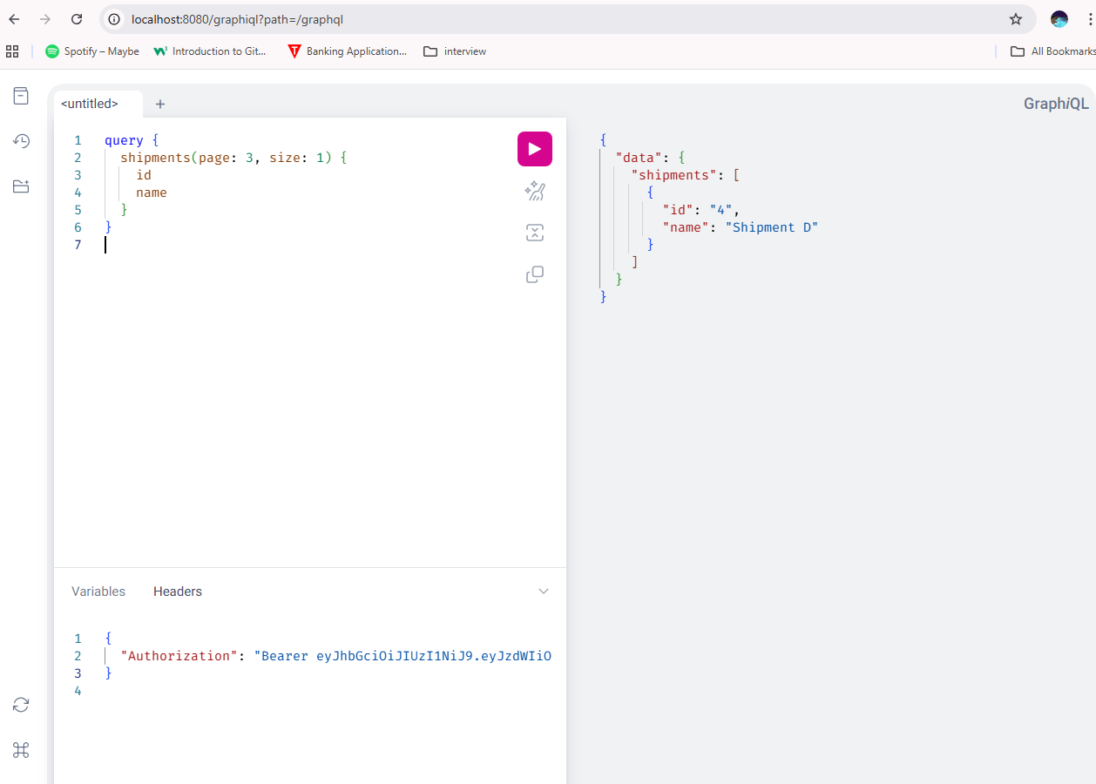

Page size
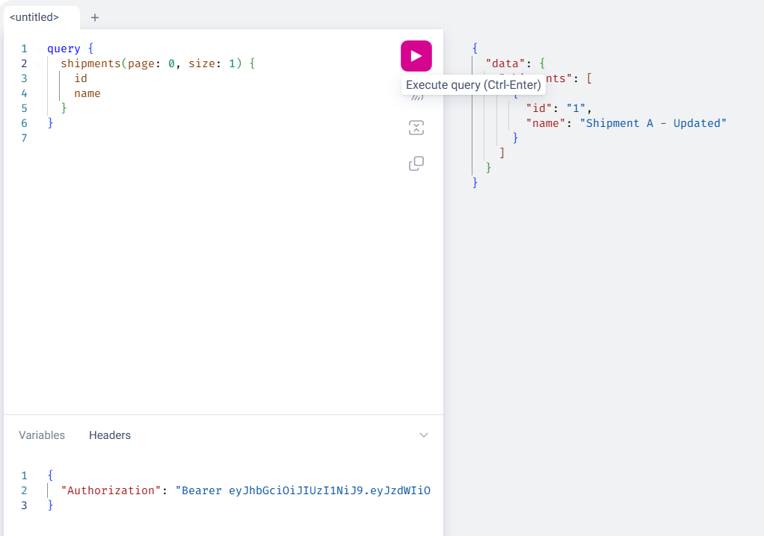
Employee can’t add shipments:
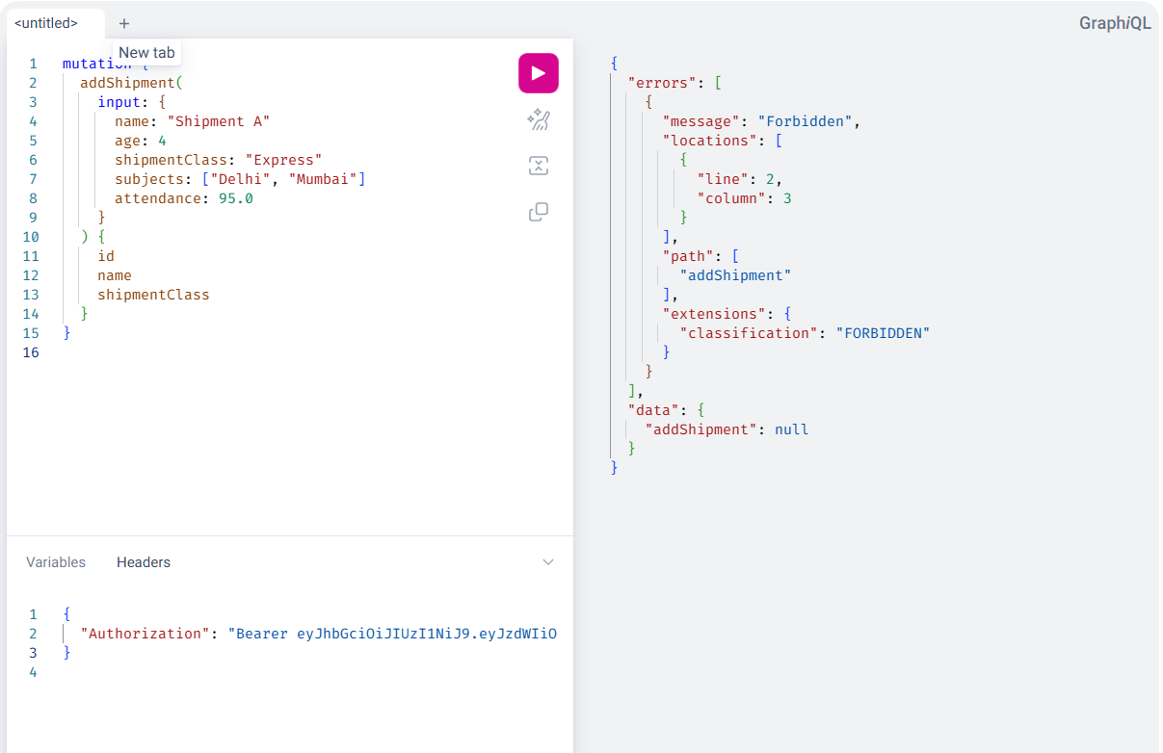

Add mutation:
mutation {
addShipment(
input: {
name: "Shipment A"
age: 4
shipmentClass: "Express"
subjects: ["Delhi", "Mumbai"]
attendance: 95.0
}
) {
id
name
shipmentClass
}
}
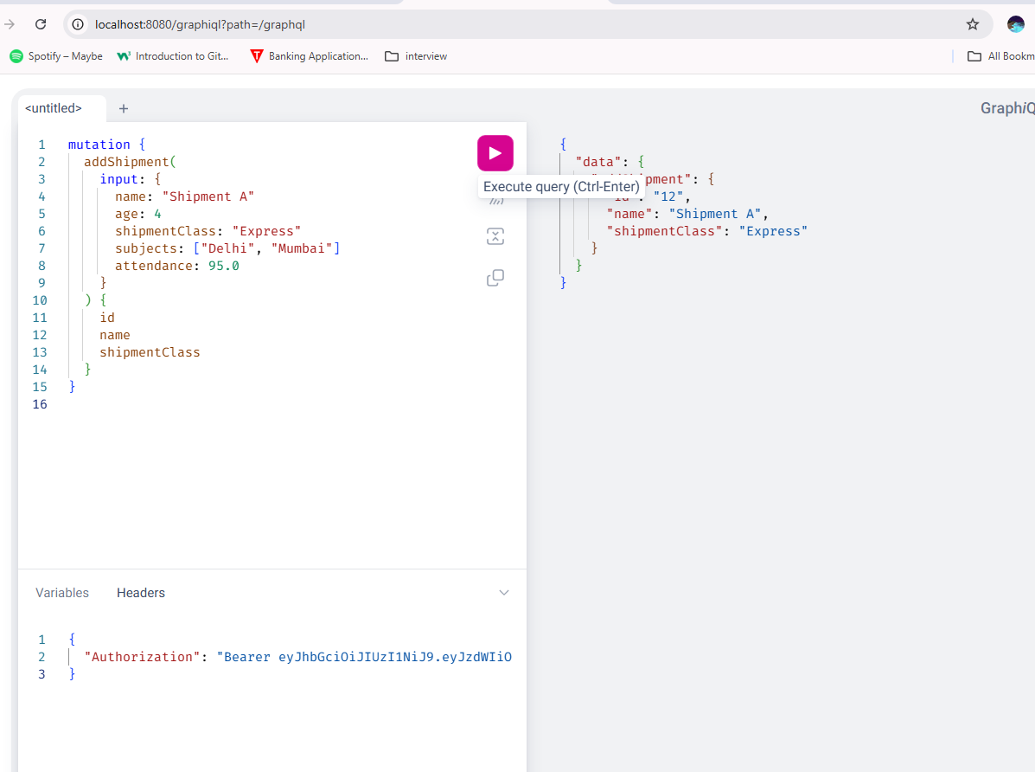

Frontend:
in case of error
